# **INVENTORY MANAGEMENT SYSTEM**

Team Members:

Guffrana Anjum

Alluri Praveenya

Andugula Anusha

**Project Description:**

The Automated Inventory Management System (AIMS) is designed to streamline and optimize the tracking, procurement, and usage of raw materials and finished goods for a large-scale manufacturing company. This system aims to enhance operational efficiency, reduce costs, and improve decision-making by providing real-time visibility into inventory levels and automating key processes.

Objectives:

* **Real-Time Inventory Tracking**: Monitor the availability of materials and products across multiple production units and warehouses.
* **Automated Reordering**: Implement automatic purchase order generation when inventory levels fall below predefined thresholds.
* **Warehouse Management**: Facilitate the management and transfer of raw materials between different warehouse locations.
* **Reporting and Analytics**: Generate insightful reports on inventory turnover, demand forecasting, and discrepancies.
* **Alerts and Notifications**: Provide timely alerts for low stock, shipment delays, and inventory discrepancies.

**Required Modules**:

To run the project, the following Python modules need to be installed:

1. pandas - For data manipulation and analysis.
2. smtplib - For sending email notifications.
3. email.mime - For constructing email messages.
4. Need to Run **main.py** file.

**Inventory Management System Operations:**

**1.Product Management:**

* **Add Material**: Input new materials into the system, including details like name, category, and quantity.
* **Update Stock**: Modify stock levels for existing materials, including increases or decreases based on sales or new deliveries.
* **Display Stock**: View current inventory levels and detailed information about each material.

**2. Stock Monitoring and Reordering:**

* **Check Stock Levels**: Continuously monitor inventory levels.
* **Automatic Reorder Trigger**: Automatically initiate a reorder process for
* materials falling below predefined stock thresholds.
* **Reorder Notification**: If no materials need reordering, generate a message indicating sufficient stock levels.

**3. Warehouse Transfer Management:**

* **Manage Transfers**: Oversee the transfer of materials between different warehouses, including tracking progress and handling delays.
* **Delay Alerts**: Send email notifications via SMTP when transfer delays exceed a specified duration.

**4.Reporting Functions:**

* **Inventory Reports:** Generate reports detailing current inventory levels and status.
* **Sales Reports:** Produce reports analyzing sales trends and performance.
* **Order Reports:** Create reports on purchase orders and their statuses.

**5.User Authentication and Security:**

* **Secure Login:** Implement a login system to authenticate users securely.
* **Access Control:** Define user roles and permissions to control access to sensitive inventory data.

**Sample Input and Output:**

**1.Authentication :**

Input:

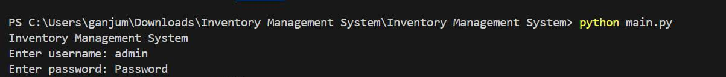

Output:



**2. Update Inventory:**

Input:



Output:



**3. Add New Material:**

Input:

Output:



**4. Check Reorders:**

Input:



Output:



**5. Manage Transfers:**

Input:

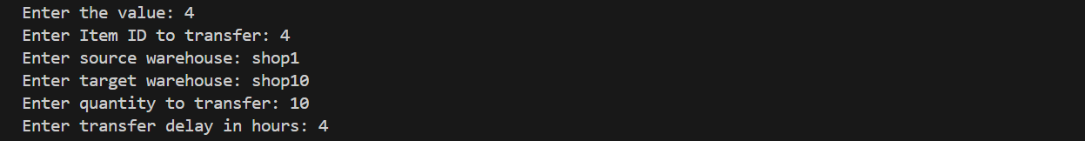

Output:



**6. Generate Records:**

Input:



Output:

**7. Display Stock Levels:**

Input:



Output:

**8.Exit:**

Input:



Output:



**Conclusion:**

The Automated Inventory Management System is a strategic initiative aimed at transforming the inventory management process for the manufacturing company. By leveraging technology to automate and streamline operations, the AIMS will contribute significantly to the company’s efficiency, cost-effectiveness, and overall competitiveness in the market.

# 